**Team Members**

Luke Shi 200608140

Haniah khan 200687050

Branden Wheeler 190197360

Ninam Rai 200619540

Luke Aikman 201652750

Naimo Yasin 201640360

Amirhossein Kompanizare 130783830

**Roles**

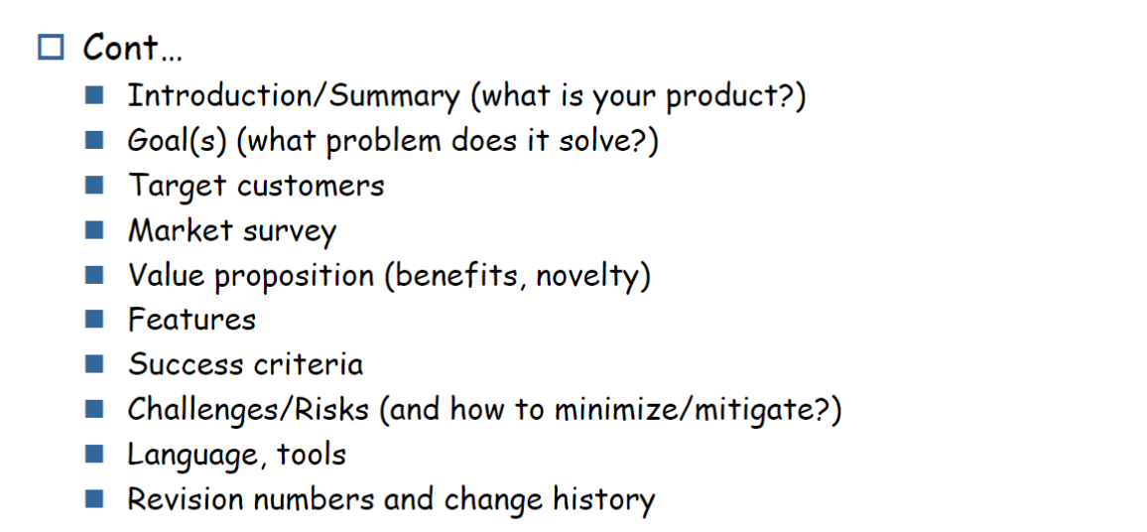

Luke Shi - Introduction/Summary

Amirhossein Kompanizare - Goal(s), Features

Haniah khan - success criteria

Luke Aikman - Target customers, value proposition

Branden Wheeler -Languages/tools, market survey

Ninam Rai - Challenges/Risks

Naimo - Revision numbers and change history